Nature Scavenger   
Hunt

Draw pictures of what you observed today!

|  |  |  |
| --- | --- | --- |
| Bird 🐤 | Animal Print 🐾 | Flower 🌼 |
| Trees 🌳 | Rocks 💎 | Insects 🐝 |
| Something Rough 👐 | Something Smooth 👐 | Something Wet 💦 |

Find and Collect

|  |  |  |  |
| --- | --- | --- | --- |
| Red or Pink Flower  Free Cartoon Pink Flower, Download Free Cartoon Pink Flower png images,  Free ClipArts on Clipart Library | Rough Rock | Green Leaf | Stick |
| orange flower clipart - Clip Art LibraryYellow or Orange Flower | Smooth Rock  48 Cartoon Of River Rock Texture Illustrations & Clip Art - iStock | Brown Leaf | Acorn |
| Blue or Purple Flower | Shiny Rock  Semi Precious Gemstones Stones And Mineral Stone Isolated Dice Colorful  Shiny Crystalline Vector Illustration Royalty Free Cliparts, Vectors, And  Stock Illustration. Image 80721976. | Yellow Maple Leaves Fall Clip Art - Polyvore - ClipArt Best - ClipArt BestYellow Leaf | What cool thing did  you find? |

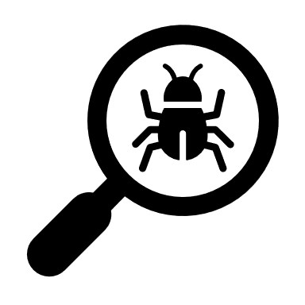

Take your items home and explore them more with a magnifying glass.